**GROUP NUMBER - FOR SOLO (just put your full name)**

**Members:**

Federico Gajo Jr

**PROBLEM:**

1. No system yet to publish and introduce their products.

**Solution:**

1. I will create a website for their products so that they can easily introduce it to the market.

**Project title:**

S.O.S Website

**Project Objectives:**

**To introduce and encourage more people to use personalize organic perfume.**

**Target Users/Audience:**

Gender: All Gender

Age: All ages

Location: Nationwide

**Introduction:**

Sense of Scents is a small starting business that sells personalize perfume.

**WIREFRAME**

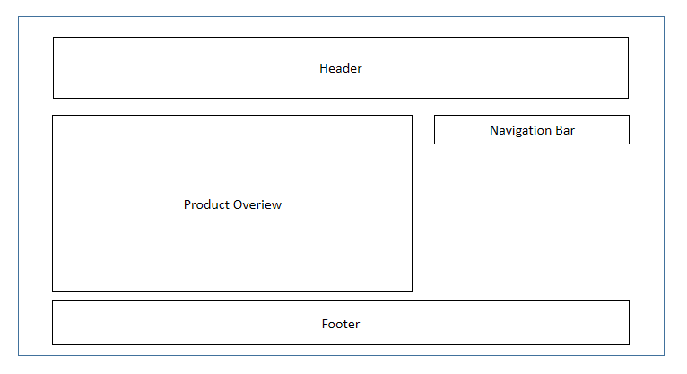

**SITE MAP**

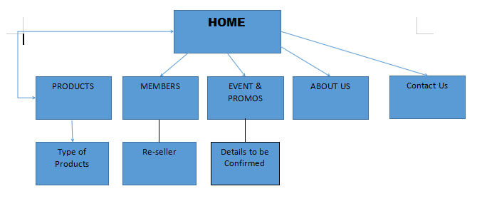

This is the initial SITE MAP proposal for website

**Features:**

* Costumer will able to see all the products and details via mobile or PC.
* Costumer can apply to be a re-seller.

**NOTE:**

**CREATE A FOLDER IN THE Gdrive link. Filename should be the Grp number and for solos filename should be your Firstname, lastname.**